# 

KNOW YOUR PROJECT (KYP)

**< Karmani >**

**<Feb 2023>**

|  |  |  |  |  |
| --- | --- | --- | --- | --- |
| **Sl. #** | **Modified Date** | **Version** | **Modified By** | **Description** |
| 1 | 12-02-2023 | Karmani 3.1.004 20130212 | Dev_Epic | Document created |

Table of Contents

**1.** **INTRODUCTION:** 3

**2.** **PROJECT FOLDER (SHAREPOINT)** 3

**3.** **TECHNOLOGY STACK** 3

**4.** **DATABASES** 4

**5.** **ARCHITECTURE DIAGRAM** 4

**6.** **APPLICATION AVAILABLITY ONLINE/OFFLINE** 5

**7.** **PROJECT CONTACTS** 5

**7.1.** **CUSTOMER:** 5

**7.2.** **EPICMINDS:** 5

# **INTRODUCTION:**

KSWDC (Karnataka State Women Development Corporation) intends to do a comprehensive base line survey of Transgenders living in Karnataka to collect various information such as Health, Socio economic, Education, Housing details etc. and provide various benefits in future by the Government of Karnataka directly to the Transgender Community.

# **PROJECT FOLDER (SHAREPOINT)**

Projects > EDCS > Karmani

# **TECHNOLOGY STACK**

|  |  |
| --- | --- |
|  | **APPLICATION STACK** |
| **FRAMEWORK** | Front End: React v18, API: .net 6 |
| **DATABASE** | Dev: 13.234.57.114 Name: Dev_TG  UAT: 3.142.159.237 Name: Dev_TG |
| **TOOLS** |  |
| **APPLICATION SERVER** | Dev: <http://13.234.57.114:9013/>  UAT: <https://karmani.epicmindsitapi.in/> |
| **SMS GATEWAY** | MOBKAR – Mobile Karnataka |
| **EMAIL GATEWAY** | None |
| **FRONT END API’s** | None |
| **Payment Gateway** | None |
| **Sakala Interface** | None |
| **API Integrations** | Dev: <http://13.234.57.114:9014/>  UAT: <https://karmaniapi.epicmindsitapi.in/> |

# **DOCUMENTATION:**

|  |  |  |
| --- | --- | --- |
| **SL#** | **Folder Name** | **Path** |
| 1 | 01-Invision | Projects > Karmani > 02-Outputs > 01-Invision > .TXT |
| 2 | 02-UserStory | Projects > Karmani > 02-Outputs > 02-UserStory > User Stories_ Surveyor_KarmaniV1_2022-11-22 |
| 3 | 03-Roles | Projects > Karmani > 02-Outputs > 03-Roles > 20221121_Roles vs Activities_Karmani.xlsx |
| 4 | 04-CodeTables and Status | Projects > Karmani > 02-Outputs > 04-Code Tables and Status > 2022-12-08_CodeTable-ENG-KAN.xls |
| 5 | 05 Data Model | Projects > Karmani > 02-Outputs >05 Data Model>20221205_Data_Model.xls |
| 6 | 06 DB Script | Projects > Karmani > 02-Outputs > 06 DB Script |
| 7 | 07-Json | Projects > Karmani > 02-Outputs >09-Json |

# **CODE REPOSITORY:**

**BACKEND:**

BITBUCKET – <https://bitbucket.org/edcs-karnataka-gov/edcs_karmani_api/>

**Front End:**

BITBUCKET - [https://bitbucket.org/edcs-karnataka-gov/edcs_karmani/](https://bitbucket.org/edcs-karnataka-gov/edcs_karmani/src/master/)

# **SERVERS AND DATABASES:**

**PROCUCTION:**

|  |  |  |  |  |  |  |  |
| --- | --- | --- | --- | --- | --- | --- | --- |
| Slno | IP address | Karmani Server | Karmani Server DB | Type | Additional Software | User Name | Password |
| 1 | 3.142.159.237 |  | Dev_TG |  |  |  |  |
| 2 |  |  |  |  |  |  |  |
| 3 |  |  |  |  |  |  |  |

# **ARCHITECTURE DIAGRAM**

**Flow Diagram**

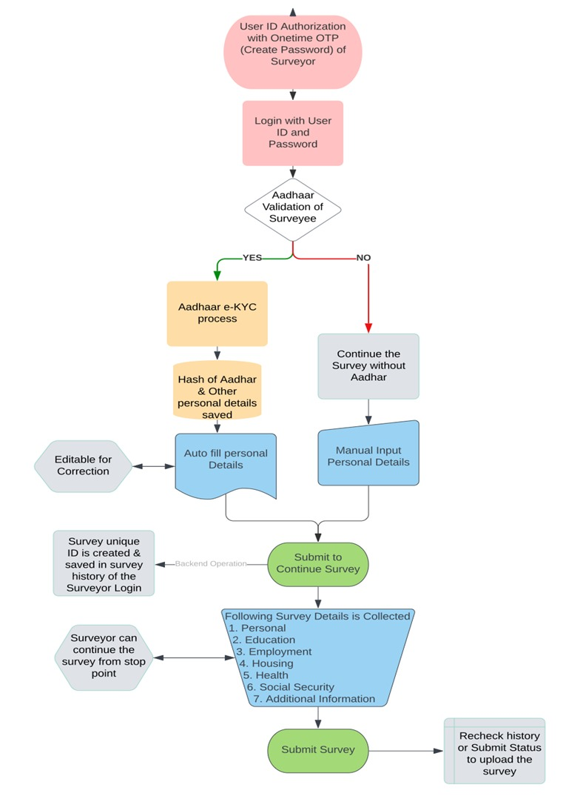

# **APPLICATION AVAILABLITY ONLINE/OFFLINE**

Online

# **PROJECT CONTACTS**

## **CUSTOMER:**

|  |  |  |  |
| --- | --- | --- | --- |
| Name | Title | Contact # | Email |
| Harsha S | Project Manager | 7676969359 | Pmm1@karnataka.gov.in |
| Pradeep N | Operations Manager | 9880001375 | omm1@karnataka.gov.in |
| Sachin H EDCS | Senior Functional Data Analyst | +91 9176031855 | Sfda1m1@karnataka.gov.in |
|  |  |  |  |

## **EPICMINDS:**

|  |  |  |  |  |
| --- | --- | --- | --- | --- |
| Name | Contacts | Title | Contact # | Email |
| Naveen Kumar | Primary | Manager-BA | +91 7892841188 | naveenk@epicmindsit.com |
| Sujay S | Secondary Contact | BA | +91 8971007636 | sujays@epicmindsit.com |
| Pankaj Kumar | Secondary Contact | Technical Manager | +91 91485 78005 | pankajk@epicmindsit.com |